Welcome Pack 2022

Welcome to Orsett Heath
Academy
I am delighted to welcome you to Orsett Heath Academy and to share a small insight into our new school and the special years ahead.
Orsett Heath Academy opened its doors to our first cohort in September 2020 and it is a year everyone associated with the school has been very proud of. Over the course of the past two years, we have looked to begin establishing an exciting and ambitious ethos of high expectations and achievement together. However, you, as our new cohort will also play a pivotal and historical role in establishing Orsett Heath as an excellent school for the community it serves.
All of the fundamentals that underpin achievement in an excellent school have been in place from day one at Orsett Heath; high expectations, a broad and balanced curriculum, first class teaching by experienced teachers, strong pastoral care, an exceptional extra-curricular offer and a strong sense of community.
Partnership working also forms a key part of our ethos and development; indeed, the location of our interim site at the home of Thurrock Rugby Football Club emphasises this, as well as our close proximity to Thurrock Harriers Athletics Track. We look forward to continuing to strengthen our relationships with these partners further and ensuring that the pupils and whole community benefit from this unique relationship and large green field site.
We have been delighted with the highly positive responses Orsett Heath Academy has received through both pupil and parent voice within the short time the school has been open, and we are committed to continuing to develop the school in partnership to ensure we are providing students with a high quality education. With this commitment, we aim to develop our strengths in teaching and learning, and pastoral and pupil support, to ensure that your school experience is both inspiring, challenging and memorable; providing you with the very best start to your future lives.
We very much look forward to meeting you soon and to welcoming you to the academy on the first day of school.
Sian Rawson
Head of School
Contents
 | Page
School values and ethos | 3
Equipment for school | 4
School uniform | 5
Personal and lost property | 6
The school day | 7
Dates for your diary | 8
School meals | 9
Free school meals/Home to school transport support | 9
Medicine, Illness and Injury | 10
Attendance, Punctuality and Data Collection | 11
Safeguarding and Pastoral care | 12
Subject information | 13-14
Homework | 15
Expectations | 16
WisePay Payments System & Communication Home | 17
School Closure | 18
Keep in touch | 19
Any questions? | 19

The School Values and Ethos

Orsett Heath Academy will be characterised by its passionate and unrelenting drive to ensure that every one of its students makes extraordinary progress, achieves exceptional standards and realises his or her huge potential. This will take place within an academy where best practice is commonplace, which prides itself at being at the cutting edge of innovation and next practice. It will have a strong culture of performance through sport and the arts that is enhanced by its unique location.
Our Core Values were decided and set by our students in September 2020. They are:
Courage
We aim to be brave, take risks and try to tackle our challenges in the best ways we can to achieve success.
Effort
We aim to put high levels of effort in to all our work and wider school life to succeed to our full potential.
Potential
We aim to reach our full potential by working hard, always trying our best and taking advantage of new opportunities.
Respect
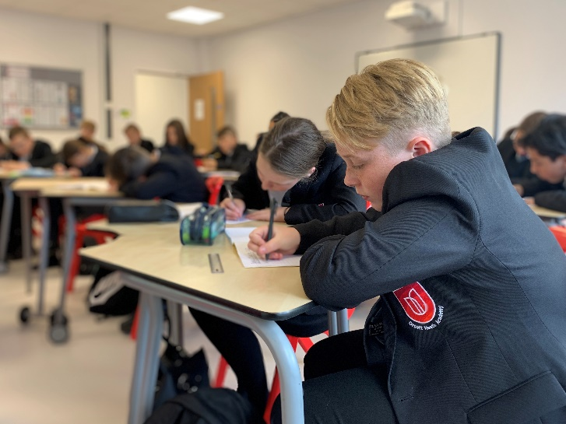
We aim to respect each other, staff, the school, and the wider community to make sure everyone feels welcomed.

Equipment for school

Please ensure that your child is fully equipped for each day at school. Students arriving without basic writing equipment or the necessary resources for a lesson cause delay and this disadvantages the student concerned and hinders them in making progress in their learning.
All students are expected to provide the following essential equipment for their work in school:
- Pens with black ink only
- A 30cm ruler
- A rubber
- Pencil and pencil sharpener
- Protractor
- Compasses
- Scientific calculator
- PE kit, brought in on the appropriate day and taken home again

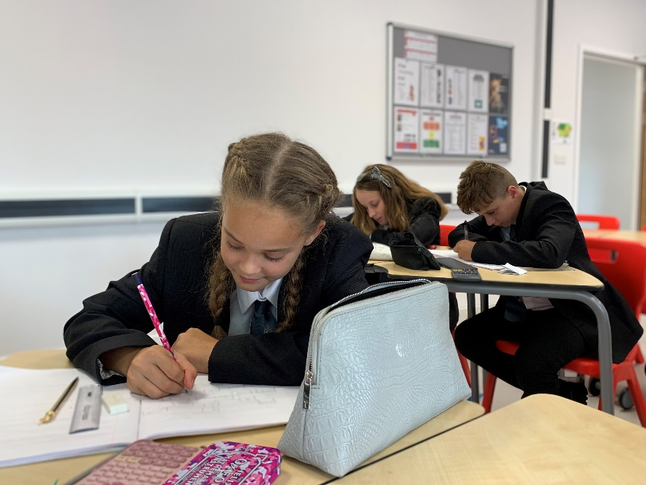
During the first few days with us in September, students will also be given a green and purple pen for school work, which will also form part of their essential equipment. These will need to be replaced by parents/carers where lost or damaged.
Students will also be required to have a sketchbook for Art. These can be bought from the Art Department via WisePay, details of which will follow.

School uniform
School uniform will be an integral part of creating our new school culture. We expect all students to wear full uniform, both in school and on the journey to and from school. All items that are specific to the Orsett Heath uniform will be available from our two uniform suppliers:
Uniformwise
(https://www.uniformwise.co.uk)

Snappy Schoolwear
(https://www.snappyschoolwear.com/)

This includes the school blazer, school tie, school jumper, P.E. shorts, P.E. leggings and P.E. top, which can be ordered online and either delivered to your home address or collected in store.

Our uniform expectations are as follows:
- School Blazer: With school badge.
- School Tie: With school badge.
- School Jumper (optional): With school badge.
- School Shirt: Plain, opaque white cotton or cotton/polyester, long or short sleeved. Conventional design to be worn with a tie. No revere collars and no polo shirts.
- School Trousers: Plain black, business-style trousers, full length. Trousers should not be denim, corduroy, brushed cotton, stretch material, ‘skinny’, chinos or ‘jeans style’.
- School Skirt: Plain black, no shorter than 2 inches above the knee. Formal presentation, free flowing either straight or pleated. No lycra style skirts to be worn.
- Shoes: Black, conventional style shoes without heels and with black laces. No designer or trainer-style shoes to be worn, no Timberland boots or shoes, no shoes with logos, coloured piping, tags or laces.
- Tights: Plain black and opaque, 70/120 denier plus, must be worn with school skirts. Socks must not be worn with skirts.
- Socks: Black, dark grey, dark blue to be worn with trousers.

Further to this, please see the below:
- Jewellery: One small wristwatch may be worn but no other jewellery; this includes earrings.
- Watches: must be removed during P.E. lessons.
- False nails: Are not permitted, whichever length, for Health and Safety purposes.
- False Eyelashes: Are not permitted.
- Hairstyles: Students’ hairstyles should complement school dress. Extreme styles and colours are not acceptable; hair should not be shaved or patterned.

Our P.E. kit expectations are:
- Shorts: Performance shorts with Orsett Heath badge available from one of our suppliers.
- P.E. Top: Short sleeve training top with Orsett Heath badge available from one of our suppliers.
- Training Shoes: To be used specifically for indoor P.E. These should not be basketball style trainers or Converse/fashion trainers. All should have laces.
- Socks: White sports socks or red football socks, also available from one of our suppliers.
- Performance sport leggings, training trousers, rain jackets and zip training tops are also optional. If you deem these items as necessary, they must be purchased from one of our suppliers as they are branded products.
- We also strongly recommend that the students wear a gum shield for Rugby and Hockey, studded boots for Ruby and Football and shin pads for Football and Hockey.
Personal and lost property

Lost Property
It is important that all items of clothing and equipment are clearly and permanently marked. This helps to prevent errors and allows us to return lost property to its owner promptly. Lost property will be received at the Main Office and kept securely. If your child loses any items, they should check the Office first and inform their Tutor.

Mobile Phones, MP3 Players, Headphones and other electronic devices
These should not be seen or heard whilst on school site, except when used for learning as instructed by teaching staff. These items will be confiscated if they are seen by staff at any other time. Any items that are confiscated will be placed in the Main Office safely and returned to a parent only after 3.05pm on the day of confiscation. The school cannot be held responsible for the loss of, or damage to, any item of this type that is brought onto the school premises. Students are advised not to bring any items of monetary or sentimental value to school.

Other items which must not be brought into school
- Laser pens or pointers: These are a potential health and safety hazard
- Fizzy drinks: Especially ‘energy’ drink such as Lucozade or Red Bull
- Chewing gum: Students are not permitted to chew gum through the school day
- Multi-packs of sweets: Students are specifically not allowed to bring multi-packs of snacks or drinks to school for sale to other students
- Solvents: Including correction fluid and permanent marker pens
- Alcohol: Of any description
- Offensive weapons: Of any description, or items which can cause personal injury if mishandled e.g. long bladed scissors
- Smoking materials: Including matches and lighters
- Drugs: Including prescription drugs, unless given to the school First Aider. The only exceptions to this are an asthma inhaler or an Epipen, which need to be carried by students as part of their agreed Care Plan.

The school day
Year 7 will start school at Orsett Heath on Monday 5th September 2022 at 08.35am
The school day will operate slightly differently on Mondays by having a shorter Period 6 lesson, in addition to the usual five lessons. Period 6 allows for the delivery of the Elective Curriculum.
There are many clubs and sporting events that run both before and after school, which your child may wish to attend. Timetables for these clubs will be provided in the first few weeks of September.
Dates for your diary
Here are the key dates you will need for your diary in the coming academic year:

AUTUMN TERM 2022

Non Student Day Thursday 1st September 2022 – STAFF TRAINING

Non Student Day Friday 2nd September 2022 – STAFF TRAINING

First day of Term Monday 5th September 2022 - Year 7 only

Tuesday 6th September 2022 - WHOLE SCHOOL

Half Term Monday 17th October 2022 – Friday 28th October 2022

Last day of Term Friday 16th December 2022

SPRING TERM 2023

First day of Term Tuesday 3rd January 2023

Half Term Monday 13th February 2023 – Friday 17th February 2023

Non Student Day Monday 20th February 2023 – STAFF TRAINING

Last day of Term Friday 31st March 2023

SUMMER TERM 2023

First day of Term Monday 17th April 2023

Bank Holiday Monday 1st May 2023

Half Term Monday 29th May 2023 – Friday 2nd June 2023

Last day of Term Friday 21st July 2023

School meals
Students must not leave the school site during first or second break.
Every day we offer a variety of nutritionally balanced, freshly prepared snacks, meals, and a range of drinks at both breaks and before school. These include fresh rolls and sandwiches, yoghurts, fresh fruit and hot meals. There is always a vegetarian option available.
An example of the range of food offered can be seen below. Please note that not all options are available every day.
Breakfast | Break | Sweet Treats & Snacks
Porridge pot with toppings £1.00  Yoghurt pot with fruit £1.00  Bacon/sausage roll £1.05  Fresh fruit pots 70p | Fresh pizza bread/slice £1.05  Sausage roll £1  Waffle 65p  Chicken goujons £1.50  Nacho’s £1  Hot baguette £1.80 | Cake slice 85p  Cookie £1  Traybake 85p  Fruit salad pot 70p  Whole fruit 40p
Grab and Go | Main | Drinks
Filled sandwich £1.10  Filled baguette £1.80  Cold dessert pot £1  Traybake 85p  Homemade muffin £1 | Meal deal £2.30  Main meal £1.85  Vegetarian meal £1.85  Jacket potato £1.10  Jacket potato with filling £1.85  Vegetable portion 60p  Hot dessert 75p  Salad portion £1.85 | Water (Large) £1  Water (Small) 70p  Suso £1  Cuplet 70p  Flavoured water £1  Capri sun £1  OMJ Cartons 75p  Drench £1/50  Radnor Cartons 75p  Homemade smoothie £1  Aqua Splash £1
*Please be aware that prices and menus are reviewed regularly and, therefore, they may differ in September.
Alternatively, students may bring a packed lunch with them and eat this in the Canteen area or outside seating areas. Eating and drinking in the school, other than in the designated areas, is not allowed.

Free school meals/Home to school transport

If you think that your child may be eligible for free school meals, or home to school transport, please contact Thurrock Borough Council Awards and Benefits Department – 01375 652882 or, go to https://www.thurrock.gov.uk/home-to-school-travel-support/apply-for-support where you will find further information.
Medicines and Illness or Injury at School
Medicine: In accordance with the national guidelines for schools, the school cannot accept any medicines that are not prescribed by a healthcare professional. However, we will stock a supply of generic paracetamol that can be accessed by students in emergencies, as long as the school has recent written parental consent. No medications will be issued without written parental consent – we cannot accept telephone or email permission.

Prescription Only Medicines (POM) - these can only be brought in to school by the parent/carer (not the child) and must be logged in school at the office. Written parental consent will be required. POM will not be accepted if they are single dosage (once a day) and can be taken before the start of the school day. For instance, most hayfever remedies and medicines for the treatment of ADHD, can be administered in a single dose at home before the child comes to school. Full guidelines and consent form can be found in the booklet entitled “Supporting students with medical conditions and situations in school: Handbook for Parents” 2020 which accompanies this information handbook.

Illness or Injury at School: Pupils who are ill or who are injured at school are referred, if appropriate, for First Aid care. Every effort will be made to contact a parent/guardian without delay if it is considered that a child should be taken home or to hospital. To this end, it is essential that we have up-to-date contact information for parents, guardians and other responsible persons. In the event that parents/guardians are not available and the school has serious concerns about a students’ wellbeing, an ambulance will be called. Please note that students must not phone or text home themselves and asked to be picked up. All decisions regarding allowing a student to return home in the event of their feeling unwell will be made by a senior member of staff and all contact with parents and carers will be made by the school office.

Students who are unwell should NOT use mobile phones to contact home. All students who feel unwell during the school day must ask a member of teaching staff to refer them through the First Aid system; someone will then appropriately assess the situation and arrange contact with parents where necessary.
Return to school following illness: If your child has suffered from an infectious or contagious illness, please check with the school regarding an appropriate recovery period before your child returns to school. Please send a note in with your child when he/she returns, detailing the dates of absence and return and the nature of the illness.

Attendance, punctuality and data collection
Attendance: Every pupil should aim for 100% attendance. If a student has an attendance level of 90% at the end of the school year, it means that 4 whole weeks of lessons have been missed. Children attend five lessons per day, so 90% attendance equates to 100 lessons missed in a school year.
Punctuality: Students are expected to be on the premises before 8.30am, to remain on the school site throughout the school day and to resister promptly at both the beginning and end of the school day. Parents and guardians are responsible for their child’s attendance and timekeeping. Students who arrive late to registration are detained for ten minutes after school without prior notice to parents/carers. Students who are late twice or more in any one week are detained for longer, but with prior notification. Lateness may be recorded as unauthorised absence. Repeated lateness is a serious matter and will be dealt with by the Educational Welfare Officer or via a Penalty Notice issued by Thurrock Council.
Leave of absence: Leave of absence may be authorised for necessary reasons, such as medical and dental appointments that cannot be made outside of school hours. Students must bring a letter from their parents to their Form Tutor which states the time, date and nature of the appointment; this must be authorised by the Form Tutor on the morning of the absence and then handed in at Student Reception when the student signs out. Parents should make themselves known to Visitors’ Reception and students will be sent down to meet them. Students are expected to attend school before, and after, medical appointments. It is not generally acceptable for a child to be absent for the whole day due to a medical appointment.
Family holidays: Holidays in term time are not a right for parents and holiday applications will not be authorised by the Headteacher or Governors, due to their significant detrimental effect on education. In exceptional circumstances, the Headteacher may choose to grant an authorised leave of absence for part or all of the requested time. An application for any leave of absence must be made in writing to the Head Teacher.

It is worth noting that accessing cheaper family holiday prices and attending family weddings are no longer deemed as exceptional by legislation from the Department for Education and as such will not be considered an exceptional absence by The South West Essex Community Education Trust.
If parents remove pupils from the academies without authorisation, then the absence will be recorded as unauthorised and they may be issued with a Penalty Notice (currently £60 per parent per child).

If leave of absence is agreed for a specific period, then any excess will be treated as unauthorised. This will also apply when parents/carers fail to gain permission in advance.

Illness or family circumstances: Absence due to sickness and other unavoidable absence should be reported to school by parents, on the first and every day of absence, by telephone to the School Office before 9.00am. We also require a note of explanation when your child returns to school. Interventions will take place if a child’s attendance falls below 97%.
Data Collection: Personal data forms will be issued annually to maintain the accuracy of our contact information. Should your circumstances change during the course of a school year, it is essential that you let us know, so that information continues to reach you and so that we can contact you in the event of an emergency.
Safeguarding and Pastoral Care
At Orsett Heath Academy, we are committed to ensuring that all students are achieving to the best of their ability and are safe and well cared for.
If you are a pupil and you have concerns about any of your fellow students or you are experiencing difficulties of any kind inside or outside of school, there are 4 core methods by which you can report an issues, concern or worry to a member of staff:
- Pupils as Listeners – These are peers trained in supporting others. They can be identified by their badges and can be found on the PALS table every break time.
- Tutors – Tutors are the first point of call for all students, seeing them twice a day. They have regular opportunities to support students with any concerns they have.
- TooToot – If students do not want to speak to someone face to face, they can send their concern into TooToot, an app or online platform where concerns go directly to the Safeguarding Team.
- Safeguarding Team – If students wish to go directly to the Safeguarding Team, they can. Posters are around school with faces of the members of staff involved and key supportive websites students can access.
In all of the above circumstances, staff members will log concerns on CPOMS or discuss them directly with the Designated Lead Safeguard Officer.
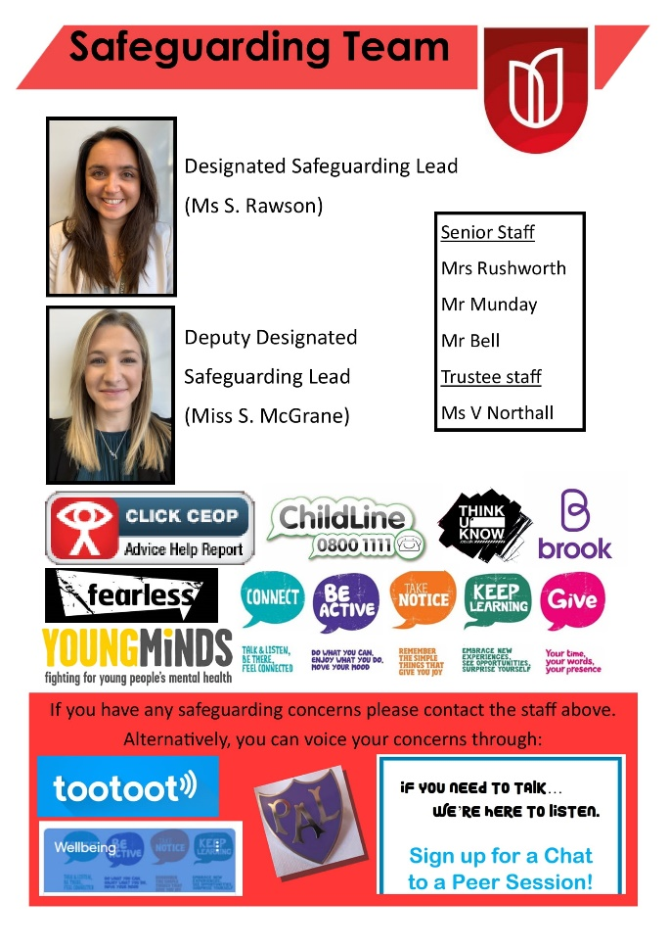
The Designated Lead Safeguard Officer will then:
- Support students in a discussion with a member of the Safeguarding Team
- Direct students to internal support
- Signpost students to specific external support strategies
If you are a parent/member of the community or member of staff here at Orsett Heath Academy and you are concerned about any of our students, please do not hesitate to contact our Designated Safeguarding Lead, Ms Rawson, or our Deputy Safeguarding Lead, Miss McGrane.
As a summary of this information and to support student awareness, our Safeguarding Team Posters will be placed in every classroom.
S.E.N.D: If you believe that your child will transfer needing support with a special educational need or disability which may require specific support, please ensure that you complete the appropriate form during the Parents/Carers’ meeting with Tutors on the evening and return it to Mrs Rushworth.
Subject Information

At Key Stage 3, our aim is to build on students’ achievements in Year 6 to develop the breadth and depth of their knowledge, understanding and skills. Students will be introduced to a wide range of subjects, developing skills they will need for lifelong learning, and enabling them to become more independent and self-aware.
In particular, the curriculum will primarily focus on ensuring that students have essential learning skills, are given opportunities to be creative and resourceful and are encouraged to have enquiring minds and think for themselves to process information, reason, question and evaluate. This will provide the foundation for Key Stage 4 and beyond.
The below grid outlines the subjects taught over a fortnightly timetable.
Ad | Art & Design
Ar | Accelerated Reader
Cc | Creative Curriculum
Dr | Drama
En | English
MfL | MFL (French)
Gg | Geography
Hi | History
It | IT
Ma | Mathematics
Mu | Music
PE | Physical Education
Ps | PSHE
RE | Religious Education
Sc | Science
Te | Tech

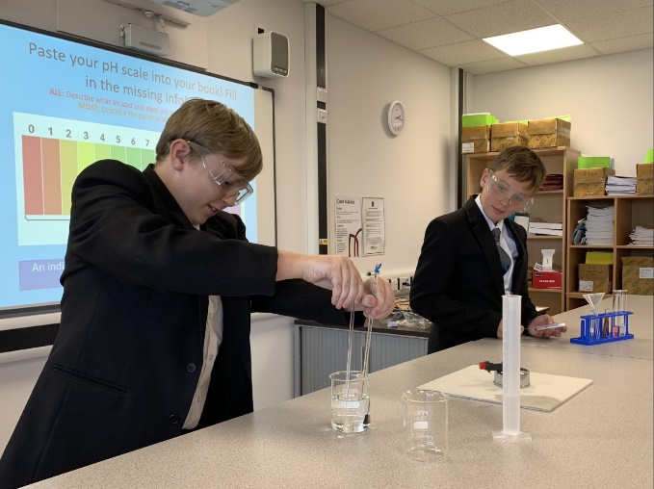
We also hold a series of curriculum days planned across the academic year to ensure accessibility for all students to different subject areas. These days may involve external visitors and speakers or educational trips and visits. There may also be availability to use specialist facilities at William Edwards School such as the dance studio, the technology rooms and the music iMac Suites.

Accelerated Reader | Accelerated Reader combines online software, classroom routines and the library to motivate students to read.
Art & Design | Art provides an opportunity to develop your expression, creativity and confidence, whilst learning about the cultural aspects of life you see around you every day. Feel free to experiment, take creative risks and be reflective during your art lessons, thinking creatively and critically.
Creative Curriculum | Creative Curriculum (CC) is a subject taught in mixed ability groups, all about the world around you. CC gives everyone the chance to be creative, and learn about morals, politics and culture. A wide range of learning techniques are used in CC lessons, including external companies coming into school to give performances and speeches
Drama | In Drama, you will develop your knowledge of performance as well as introducing key texts. Drama allows you to think creatively and work collaboratively. You will also learn communication and confidence skills. Even if you’re not one for the theatrics, there’s something in Drama for everyone!
English | The English department strives to challenge you to think deeper and analyse pieces further, introducing you to a wide range of texts. English also develops literacy, reading and writing skills, creating students capable of using these skills across all subjects and future walks of life.
French | Learning a new language is a great skill to use in later life. In Year 7, you will start learning French! You will learn the basics of the language and how to communicate effectively. Learning a new language gives you confidence and furthers communication skills.
Geography | In Geography, you will learn all about the earth beneath your feet and to embrace your place as a global citizen. In Year 7, you will look at different aspects of everyday life and develop knowledge of case studies from all over the world. Geography includes everything from tourism to climate change!
History | History not only teaches you about events from the past, but also about how this affects our future. You will develop an understanding of how our society has evolved and why the world is the way it is. You will learn to study evidence, write clearly and assess critically, giving you a whole host of skills to use in the future.
ICT | ICT is designed to provide you with a knowledge of computer skills necessary in today’s society, and help students develop a passion for subjects such as animation, marketing and video editing.
Maths | In Maths, you will learn problem-solving skills, confidence when tackling new problems and develop independence. Maths is a core subject that it not only used in other subjects but in every day life.
Music | In Music, students will learn how to identify and understand various styles of music and their relation to important social and cultural traditions and issues, identify how music has evolve throughout history and how various genres of music are connected and their specific characteristics.
P.E. | PE helps develop teamwork and communication skills. You have the chance to experience many sports, gain an understanding of those sports and acquire the knowledge and motivation to lead a healthy lifestyle.
PSHE | Personal, Social, Health and Economic education (PSHE) will be delivered through 2 hours of curriculum time a fortnight in Year 7. The curriculum time will be divided half-termly by 3 core themes: Health and Wellbeing, Relationships and Sex Education and Living in the Wider World. All aspects of PSHE will be taught as a spiral programme which includes the recurrence of these 3 core themes, as a student progresses through Orsett Heath Academy. With each delivery of the theme, the level of demand increases and learning is progressively deepened.
Religious Education | In RE, students are given a wider understanding of the beliefs, diversity and moral values of others. RE approaches current issues that you may hear about in the media and want to gain a further understanding of. You will have the chance to communicate with others and give your opinion in a respectful way.
Science | Science lessons help you to learn about the world around you and develop your practical science skills. Everything we do involves science, even if we do it unconsciously. During your science lessons, you will spend time thinking about the world around you and how it works. Science is exciting and inspiring, allowing students to work in groups, write and think logically and carry out scientific investigations.
Tech | Technology classes will be taught on a carousel between design technology, computer science and food and nutrition. Our aim in this subject area is that pupils learn how to take risks, becoming resourceful, innovative, enterprising and capable citizens.

For more information on each subject area, including the purposes of each curriculum, please go to https://www.orsettheathacademy.org.uk/subject-areas/
Homework

The core aim of homework at Orsett Heath Academy is to embed and extend work covered in class or prepare for new learning activities.
What is our rationale behind our homework policy?
- To develop research and presentation skills.
- To allow an opportunity for independent work and take responsibility for learning.
- To enhance study skills e.g. planning, time management and self-discipline.
- To promote personal and independent research and learning.
How much homework will students receive?
Pupils’ homework will be set three times per subject during the course of a half term. The tasks will include two retrieval practice quizzes (at the beginning and end of each half term), and a mid term activity. Further details about each of these tasks can be found at: https://www.orsettheathacademy.org.uk/homework/
What feedback will parents/carers receive about homework?
- Homework will be marked and assessed. Feedback will be provided to the students after each piece of work.
- High quality homework and a good work ethos will also be praised in class.
- Non-completion of homework will be sanctioned in line with the school’s behaviour policy.
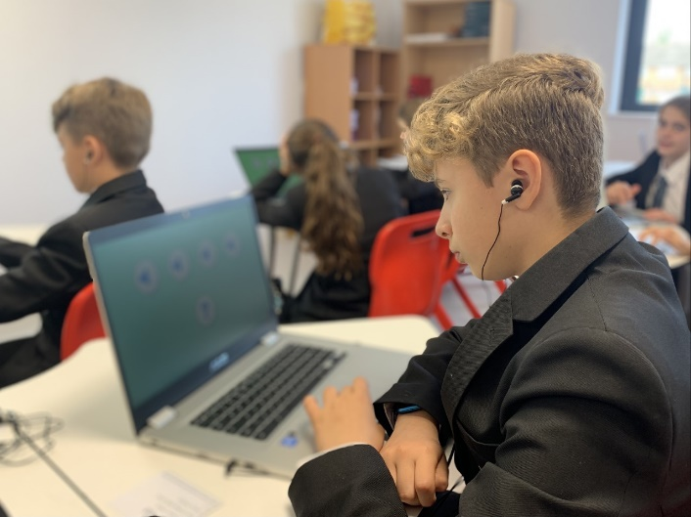
What support will be provided for homework?
- All homework will be set on Google Classroom, with due dates clear for students and parents/carers to see.
- Homework Club will run after school once a week for any student to attend if they wish to access more support with their homework.
- Homework should be appropriately differentiated for the students’ ability and circumstances.
- Training with students around time management and other study skills will be completed in PSHE lessons in Autumn 1. This will also be placed on Google Classroom for students to refer back to.
- An OHA Weekly Planner has been created which students can use to plan their time effectively during the week to keep on top of homework and other commitments – Click HERE to view
Expectations
Orsett Heath Academy has high expectations of both pupils and staff. We will have a culture of high aspiration, expectation and personal success for all our students. This is in order to provide an outstanding learning experience with a safe, well disciplined and caring environment.
In order to achieve the above, we hold the following expectations for key groups:
Staff
- Implement the behaviour policy consistently
- Model positive behaviour
- Hold high expectations for all pupils
- Provide a personalised approach to the specific behavioural needs of particular pupils
- Encourage pupils to promote the aims and values of their school in their daily lives and in the local community
- Encourage regular communication between school and home
- Record behaviour incidents

Parents
- Support their child in adhering to the expectations
- Ensure that their child comes to school regularly, on time, with the appropriate equipment
- Inform the school of any changes in circumstances that may affect their child’s behaviour
- Discuss any behavioural concerns with the class teacher or tutor promptly

Students
- Respect, support and care for each other, both in school and the wider community
- Listen to others and respect their opinions, showing empathy and understanding
- Attend school regularly, on time, ready and equipped to learn and take part in school activities
- Take responsibility for their own actions and behaviour and fully understand the consequences of poor behaviour on their own and others’ learning experiences
- Do as instructed by all members of staff (teaching and non-teaching) throughout the school day
- Be accepting of others, irrespective of any difference; for example: race, gender, sexual orientation, religion or age
- Treat the school buildings and school property with respect
- Wear the correct uniform at all times and be properly equipped for school

These expectations cover all aspects of school life including journeys to and from school, as well as break times. As well as these expectations, all students should be aware of the following school rules:
- Mobile Phones – While we know that mobile phones are important for pupil safety travelling to and from school, they should not be used during the school day. Mobile phones should be turned off and in student’s pockets or bags, throughout the entirety of the school day including break-times.
- Headphones – Must not be seen in school. If these are seen, they will be confiscated immediately.
- Uniform – School uniform must be adhered to and worn at all times. False eyelashes and nails are not allowed and jewellery should not be worn. All students should also have appropriate footwear, and should not be wearing trainers.
- Equipment – Each student must have the required equipment for each lesson.
- Attendance – Attendance is expected to be as close to 100% as students can. Students must also not be late to school or lessons.
- Hands-Off – The school has a hands-off policy, and any form of fighting or physical violence will not be tolerated.
WisePay Payments System &
Communications Home
Wise Pay: All purchases from the school are to be made through the school’s online WisePay payment system. This includes canteen purchases, trips and visit payments, extra Music tuition, and all other invoice requests. To ensure that you receive important notifications regarding your WisePay account, a correct up-to-date email address is required. Further information for WisePay is on the Cashless System Information and Consent Form contained in the Admission Information booklet, which has been sent to accompany this information handbook.

Biometric Print: With your permission, your child will have their thumbprint scanned. Please be assured that the actual thumb print is not stored on any system; instead, 8 unique points of the thumb are used to recognise your child which then means that they can use the system to purchase items from the Catering Academy.

Communication: Here at Orsett Heath, we advocate ‘being green’ and to reduce our paper usage, we send letters out to parents via our Class Charts system. Further details regarding parental log-ins for this app will be sent to you shortly. You may also request a paper copy of any communication by contacting the Main Office. Alternatively, you may, if you wish, opt out of Class Charts communication, in which case letters will be sent to you on paper.

Once you have received a letter via Class Charts, please read the contents carefully as it may require a response.
If a response is required, please reply via the Class Charts app providing the information requested.

School Closure
We are mindful of our duty to educate, care for and safeguard our students. We also know that many of our parents and carers hold key roles and responsibilities in the wider community of which Orsett Heath is a part. For these reasons, other than for scheduled school holidays and advertised non-pupil days, school will close only in exceptional circumstances, these being:
- Due to a facility malfunction in the buildings, e.g. boiler breaking down/power failure/ failure of the water supply.
- If a substantial number of staff are unable to reach school, due to severe weather conditions.

Otherwise, the school will remain open. In the unlikely event of closure, you should consult the following WEBSITES: www.orsettheathacademy.org.uk, www.heartessex.co.uk or www.bbc.co.uk/essex, and tune in to Heart Essex on 96.3FM or 102.6FM, where the closure will be either listed or announced. Should you be uncertain, assume that the school is open. In the event of the weather seriously deteriorating during the school day, students will be kept in school until the end of the afternoon and released at the normal time. In the unlikely event of an unforeseen early closure, we will endeavour to make contact with you via SMS or email (with telephone contact where necessary); no student will be released until this contact has been made.
Students will not be asked to telephone home themselves as a result of bad weather.
In the cold, students may wear coats over their school blazers while out of doors but will be asked to remove these as soon as they enter the buildings. Any thermal layers worn under school shirts must be invisible. For health and safety reasons, we cannot allow students to play with snow and students will generally remain indoors at break.

Keep in touch

We cannot wait to welcome you to Orsett Heath Academy in September. In the meantime, make sure you keep up to date with our latest news.
Any questions?

If you have a question about any aspect of the academy, please get in touch with the School Office in the first instance on: 01375 802800
The office will pass your message on to the appropriate member of staff, who will return your call and do their best to address your question or concern.
- If you have concerns of a Safeguarding or Child Protection nature, please ask to speak to Ms S Rawson.
- If you have concerns or questions relating to SEND, please ask to speak to Mrs S Rushworth.

Orsett Heath Academy
Oakfield
Long Lane
Grays
RM16 2QH
Phone: 01375 802800
Email: office@oha.swecet.org

